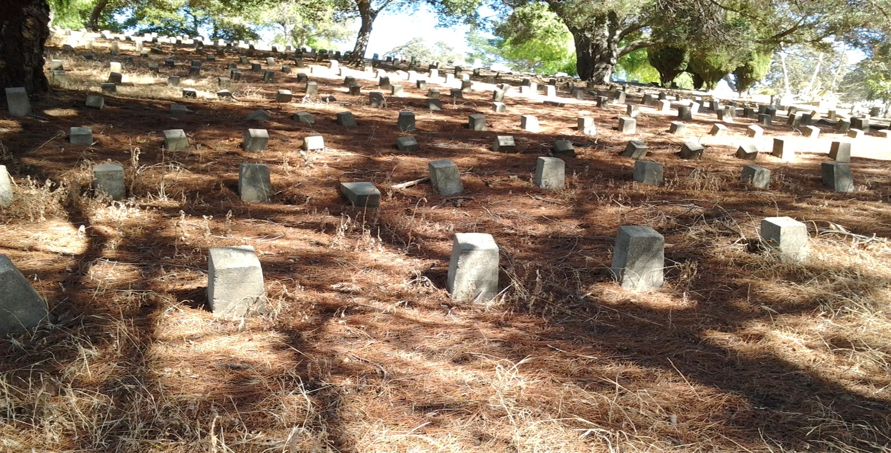
POTTER’S FIELD
BIANNUAL CLEANUP

Alhambra Cemetery Potter's Field, Martinez
(Bottom of Hill)

Saturday Oct 28, 2017
9 am - 2 pm

Sponsors: City of Martinez, E Clampus Vitus,
Martinez Historical Society, Potter's Field Restoration Project, SOLS

Pay your respects to the many people buried there. Help clean-up debris and remove weeds from around the many graves or close the Chinese Funerary Burner site for winter of those that built our communities and made them what they are today, the laborers, builders, restaurant staff, railroad workers, farmers, veterans of our past and many more.

​ ​Lunch for all volunteers generously provided by E Clampus Vitus
Morning Refreshments, Water, First Aid, Bug Spray & Suntan Lotion for
Potter's Field Project volunteers generously provided by SOLS.

Wear comfortable clothes, a pair of gloves & protective eye-wear. Tasks will include sand bagging, removing old mortar from brick and de-weeding around the gravesites. If you have any tools that you feel could be useful, please bring them. Otherwise tools will be provided.

For further information, donations or to volunteer:
Please contact: Joseph Palmer
Potter's Field Restoration Project Coordinator
Phone: (925) 335-9396 Email: martinezcemetery@gmail.com

